PPMS Dashboard and Report Ideas:

Resource Link 1: <https://www.projectmanager.com/guides/project-portfolio-management>

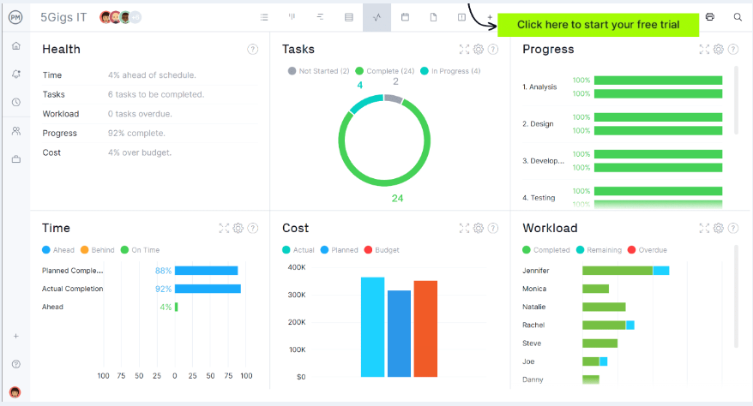

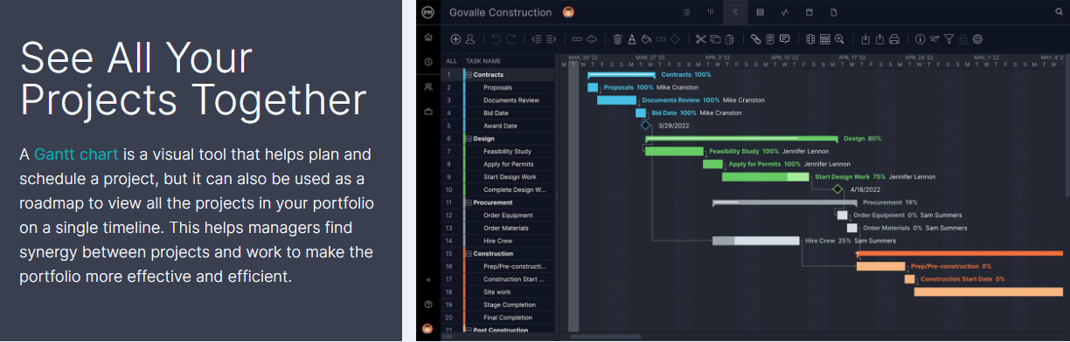

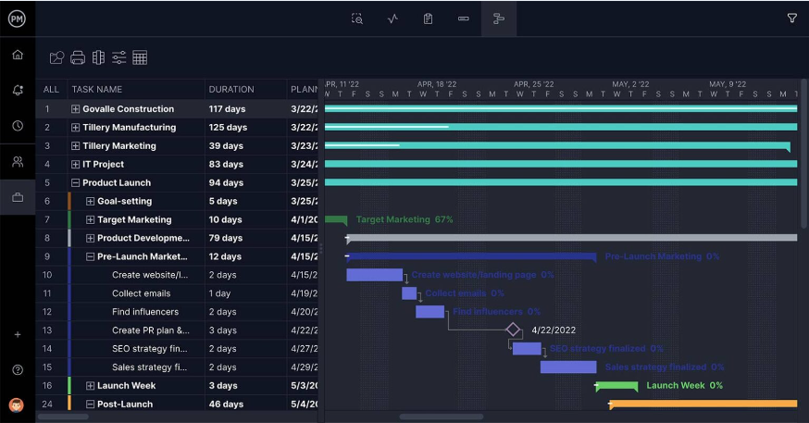

Resource Link 2: <https://meisterplan.com/blog/project-portfolio-management/project-portfolio-management/>

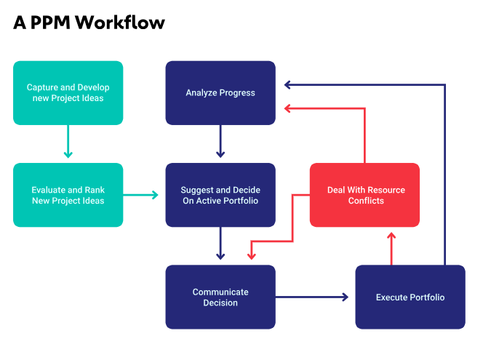

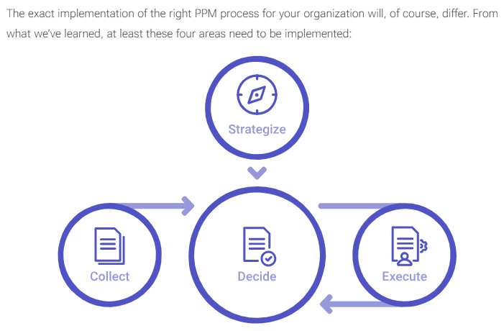

Resource Link 3: <https://www.brightwork.com/guide-project-portfolio-management>

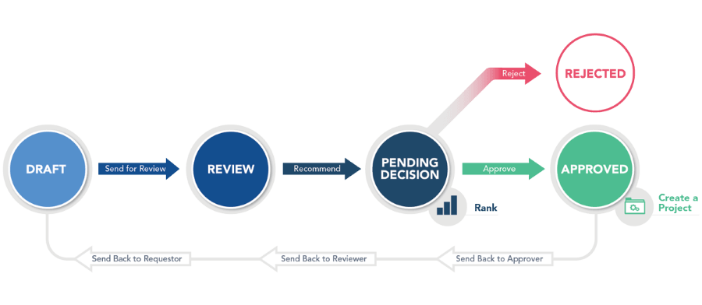

Resource Link 4: <https://www.runn.io/blog/how-to-track-project-progress>



